|  |  |  |  |  |  |  |  |
| --- | --- | --- | --- | --- | --- | --- | --- |
| **FIN AND MO NEW STOCK - 4/3/23** | | | | | | | |
| **PHOTO** | **BRAND** | **STYLE NUMBER** | **COLOR** |  | **QTY** | **MSRP** | **NOTES** |
|  | CHLOE | CHC21AS680F01 001 | BLACK |  | 1 | $1750.00 |  |
|  | CHLOE | CHC22AS680H65 26X | LIGHT TAN |  | 1 | $1750.00 |  |
|  | CHLOE | CHC22UP674G36 25M | TAN |  | 1 | $895.00 |  |
|  | CHRISTIAN LOUBOUTIN | 3225038 CM53 1000 | BLACK |  | 1 | $1790.00 |  |
|  | CHRISTIAN LOUBOUTIN | 3225038 P701 ROSY | ROSY |  | 1 | $1790.00 |  |
|  | CHRISTIAN LOUBOUTIN | 3225080 L252 | LILAC SMOKE |  | 1 | $1790.00 |  |
|  | FENDI | 8M0251 AAJD F0KUR | BLACK GOLD |  | 1 | $1390.00 |  |
|  | FENDI | 8M0251 AAJD F184R | CANDY PINK |  | 1 | $1390.00 |  |
|  | FENDI | 8M0395 AAJD F0KUR | BLACK GOLD |  | 2 | $1190.00 |  |
|  | FENDI | 8M0395 AAJD F184R | CANDY PINK |  | 2 | $1190.00 |  |
|  | FENDI | 8M0477 AKK2 F0KUR | BLACK GOLD |  | 1 | $1890.00 |  |

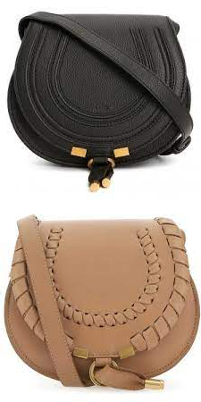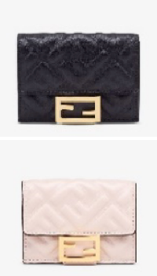

|  |  |  |  |  |  |  |  |
| --- | --- | --- | --- | --- | --- | --- | --- |
|  | FENDI | 8M0477 AKK2 F0QVL | WHITE/GOLD |  | 2 | $1890.00 |  |
|  | GUCCI | 401231 UKMBN 2572 | CAMEL EBONY/NEW ACER |  | 1 | $1890.00 |  |
|  | GUCCI | 474575 DTD5F 4340 | CLE.BLU/ CLE.BLU/CL.B |  | 1 | $1890.00 |  |
|  | JACQUEMUS | 213BA001 3065 640 | LILAC |  | 1 | $895.00 |  |
|  | MIU MIU | 5NE843 N88 F0009 | WHITE |  | 1 | $1895.00 |  |
|  | VALENTINO | 1W2B0809VSF 0NO | BLACK |  | 1 | $1990.00 |  |

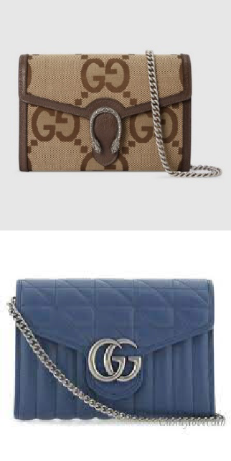

**Comments**

FINAL ORDER-1-1-1-1-1-1-1-1-1-1